**COPYRIGHT**

The author has agreed that the library, Department of Civil Engineering Thapathali Campus, Institute of Engineering may make this report freely available for inspection. Moreover, the author has agreed that permission for extensive copying of this report for scholarly purpose may be granted by the professor(s) who supervised the work recorded herein or, in their absence, by the Head of the Department wherein the report was done. It is understood that the recognition will be given to the author of this report and to the Department of Civil Engineering, Thapathali Campus, Institute of Engineering in any use of the material of this report. Copying or publication or the other use of this report for financial gain without approval of the Department of Civil Engineering, Thapathali Campus, Institute of Engineering and author’s written permission is prohibited.

Request for permission to copy or to make any other use of the material in this report in whole or in part should be addressed to:

----------------------------------------------

Head

Department of Civil Engineering

Thapathali Campus, Institute of Engineering

Kathmandu, Nepal



# Cover Page

TRIBHUVAN UNIVERSITY

INSTITUTE OF ENGINEERING

THAPATHALI CAMPUS

DEPARTMENT OF CIVIL ENGINEERING

**DESIGN OF PRESTRESSED BOX GIRDER BRIDGE**

BY

AASHISH GHIMIRE(THA074BCE002)

BISHAL SHAKYA(THA074BCE026)

EMADUDDIN AHMAD(THA074BCE032)

KUSHAL ACHARYATHA074BCE045)

MILAN JOSHI(THA074BCE046)

NIKESH DAWADI(THA074BCE048)

IN PARTIAL FULFILMENT OF THE REQUIREMENT FOR THE

BACHELOR'S DEGREE IN CIVILENGINEERING

January, 2022

Kathmandu, Nepal

# Title Page



TRIBHUVAN UNIVERSITY

INSTITUTE OF ENGINEERING

THAPATHALI CAMPUS

DEPARTMENT OF CIVIL ENGINEERING

**DESIGN OF PRESTRESSED BOX GIRDER BRIDGE**

BY

AASHISH GHIMIRE(THA074BCE002)

IN PARTIAL FULFILMENT OF THE REQUIREMENT FOR THE

BACHELOR'S DEGREE IN CIVILENGINEERING

January, 2022

Kathmandu, Nepal

# Certificate

TRIBHUVAN UNIVERSITY

INSTITUTE OF ENGINEERING

THAPATHALI CAMPUS

DEPARTMENT OF CIVIL ENGINEERING

**CERTIFICATE**

This is to certify that the work contained in this report entitled **"** **Design of prestressed box girder bridge"** in partial fulfillment of the requirement for the Bachelor's degree in Civil Engineering, as a record of research work, has been carried out by **“Aashish Ghimire(THA074BCE002)”** under my supervision and guidance in the Institute ofEngineering, Thapathali Campus, Kathmandu, Nepal. The work embodied in this report has been submitted elsewhere for degree.

_____________________________________________

Supervisor, name of Supervisor

Title

Name of the Department

_____________________________________________

Co- Supervisor, name of Co-Supervisor,

Title

Name of the Organization,

Date

TRIBHUVAN UNIVERSITY

INSTITUTE OF ENGINEERING

THAPATHALI CAMPUS

DEPARTMENT OF CIVIL ENGINEERING

**DESIGN OF PRESTRESSED BOX GIRDER BRIDGE**

By

AASHISH GHIMIRE(THA074BCE002)

A project report submitted in partial fulfillment of the requirements of the Bachelor's Degree in Civil Engineering

|  |  |  |
| --- | --- | --- |
| …………………………… | …………………………… |  |
| Name | Name |  |
| Supervisor | Internal Examiner |  |
|  |  |

|  |  |  |
| --- | --- | --- |
| …………………………… | …………………………… |  |
| Name |  |  |
| External Examiner | Head of Department, Civil |  |
| IOE, Thapathali Campus |  |
|  |  |

July, 2020

Kathmandu, Nepal

# Acknowledgements

**ACKNOWLEDGEMENTS**

I am greatly indebted to my project supervisor Professor Sakhil Manandhar for providing me with definite direction, professional guidance, and constant encouragement from the beginning of the work and moral support in many ways during study period.

I am also greatly indebted to Er. Biswa K. Balla of Institute of Engineering, for his valuable suggestion and direction to accomplish the study.

I would like to express my sincere thanks to Name, Name and Name, of Organization, for their outstanding suggestions and cooperation received during the study period.

I acknowledge the help, advice and guidance rendered by Head of the Civil Engineering Department, Ram Pd. Neupane. The support provided by Administrative staffs, Name is unforgettable.

I am also grateful to all the colleagues …………………………………………. .

**ACKNOWLEDGEMENTS**

|  |  |
| --- | --- |
| **Particulars** | **Required information / Range / values** |
| **Name of the Project** | **Design of Prestressed Box Girder Bridge at Bhedabari, Kaski** |
| Location |  |
| Zone | Kaski |
| District |  |
| Village /Town |  |
| Name of the Road |  |
| Chainage of the bridge site | - |
| **Geographical Location** |  |
| Easting |  |
| Northing |  |
| Classification of Road |  |
| Type Of Road |  |
| Terrain / Geology | Plain |
| **Information on the structure** |  |
| Total Length of the Bridge | 200 m |
| Span arrangement | 50+50+50+50m |
| Total width of the Bridge | 9.5 m |
| Number of Lanes | 2 |
| Width of: |  |
| Carriageway | 7.5m |
| Footpaths | 1m on each side |
| **Particulars** |  |
| Type Of Superstructure | Prestressed RCC Box- Girder Bridge |
| Type Of Bearings | Elastomeric Pad Bearings |
| Type Of Abutments | RCC Rectangular Abutments |
| Type of Piers | Hammerhead type pier |
| **Design Data** |  |
| Live Load | IRC Class A, 70R Wheeled, 70R Tracked |
| Net Bearing Capacity of Soil | 146-205 KN/m2 |
| Design Discharge | 516.89m3/s |
| Linear Waterway | 200m |

# Abstract

**ABSTRACT**

**TABLE OF CONTENTS**

|  |  |  |
| --- | --- | --- |
| **Chapter Title** | **Page** |  |

Cover Page 2

Title Page 3

Certificate 4

Acknowledgements 6

Abstract 7

LIST OF FIGURES 9

LIST OF TABLES 10

ABBREVIATIONS 12

CHAPTER I 13

**1.0** **INTRODUCTION** 13

**1.1General Background** 13

**1.2 Specific Background** 14

**1.2.1 History of Bridge** 14

CHAPTER II 15

**2.0 Engineering Survey** 15

CHAPTER III 16

**3.0 Geological Study** 16

**3.1 Geotechnical Study** 17

**3.1.1 Boring** 17

**3.1.2 Sampling** 18

**3.1.3 Field Test** 18

**3.1.4** **Ground water table monitoring** 21

**3.1.5 Seismicity** 22

**3.1.6 Liquefaction** 25

**3.1.1 Recommendation of Foundation Type and Depth:** 26

CHAPTER IV 28

**4.0 Hydrological Study** 28

**4.1 Hydrological Design** 28

**4.1 Site Verification** 33

CHAPTER V 35

**5.0 Detailed Design** 35

**5.1 Bridge Type Selection Criteria** 35

# **LIST OF FIGURES**

**Figure No** **Title** **Page**

# **LIST OF TABLES**

|  |  |  |
| --- | --- | --- |
| **Table No.** | **Title** | **Page** |
| 2.1 |  | 6 |
| 2.2 |  | 6 |
| 2.3 |  | 8 |
| 2.4 |  | 14 |
| 3.1 |  | 20 |
| 3.2 |  | 21 |
| 3.3 |  | 24 |
| 4.1 |  | 31 |
| 4.2 |  | 32 |
| 4.3 |  | 33 |
| 4.4 |  | 34 |
| 4.5 |  | 35 |
| 4.6 |  |  |
|  |  | 37 |
| 4.7 |  | 39 |
| 4.8 |  |  |
|  |  | 40 |
| 4.9 |  |  |
|  |  | 41 |
| 4.10 |  | 42 |
| 4.11 |  | 42 |
| 4.12 |  | 43 |

9

# **ABBREVIATIONS**

# **CHAPTER I**

## **INTRODUCTION**

## **1.0.1General Background**

Design of structures involves the designing of various types of structures such as residential buildings, bridges, multi-storied frame structures, steel towers etc. These structures are subjected to various loads such as uniformly distributed loads, uniformly varying loads, point loads, internal loads etc. which may subject the structure to shear force, axial force, bending and torsional moments. These structures serve to transfer the load to the soil on which their foundations lie, such that the structure is able to serve its purpose without risk of failure in any form.

The designing of bridges requires analysis of internal forces in the members of the structure. The designing of bridges requires sizing of members to resist the internal forces that occur in the members so as to allow the structure to appropriately serve its purpose for its intended useful life. Without proper analysis and designing of bridge according to the provided guidelines via the specified standard code (Nepal Bridge Standards-2067), the structure will not be able to serve its intended purpose and may result in failure and loss of both finances and civilian lives.

This project has been undertaken as an essential requirement for bachelor’s degree in civil engineering as specified under the course content provided by Institute of Engineering, Tribhuvan University. The project aims to analyze the proposed bridge structure, provide design and detailing as well as provide an appropriate estimate of its durability (safety) and cost of construction. All the theoretical knowledge acquired have been accordingly utilized for practical application for the analysis, design and detailing of the proposed bridge. The purpose of this project work is to be well acquainted in the practical implementations of knowledge and skills required in the field of Civil Engineering.

## **1.0.2 Specific Background**

### **1.0.2.1 History of Bridge**

Bridge is a structure that provides passage over obstacles such as valleys, rough terrain or bodies of water by spanning those obstacles with natural or manmade materials. They first begun to be used in ancient times when first modern civilizations started rising in the Mesopotamia.

From that point on, knowledge, engineering, and manufacture of new bridge building materials spread beyond their borders, enabling slow but steady adoption of bridges all across the world. In the beginning bridges were very simple structures that were built from easily accessible natural resources- wooden logs, stone and dirt. Because of that, they had ability only to span very close distances, and their structural integrity was not high because mortar was not yet invented and rain slowly but constantly dissolved dirt fillings of the bridge. Revolution in the bridge construction came in Ancient Rome whose engineers found that grinded out volcanic rocks can serve as an excellent material for making mortar. This invention enabled them to build much more sturdy, powerful and larger structures than any civilization before them. Seeing the power of roads and connections to distant lands, Roman architects soon spread across the Europe, Africa and Asia, building bridges and roads of very high quality. Modern bridges are usually made with the combination of concrete, irons and cables, and can be built from very small sizes to incredible lengths that span entire mountains, rough landscapes, lakes and seas.

### **1.0.2.2 Types of Bridges**

Arch Bridge – An arch bridge is a bridge shaped as an upward convex curved arch to sustain the vertical loads. A simple arch bridge works by transferring its weight and other loads partially into a horizontal thrust restrained by the strong abutments at either side. The arch rib needs to carry bending moment, shear force, and axial force in real service conditions. With the help of mid-span piers, they can be made with one or more arches, depending on what kind of load and stress forces they must endure.

Beam bridges – Beam bridges (also referred to as Girder Bridges) are the most common, inexpensive, and simplest structural forms supported between abutments or piers. The weight of the beam and other external load need to be resisted by the beam itself, and the internal forces include the bending moment and shear force. Only materials that can work well for both tension and compression can be used to build a beam bridge. Obviously, both plain concrete and stone are not good materials for a beam because they are strong in compression, but weak in tension. Though ancient beam bridges were mainly made of wood, modern beam bridges can also be made iron, steel, or concrete with the aid of prestressing.

Truss bridges – Truss is a structure of connected elements forming triangular units, and a bridge whose load-bearing superstructure is composed of a truss is a truss bridge. The truss members like chords, verticals, and diagonals act only in either tension or compression. For modern truss bridges, gusset plate connections are generally used, then bending moments and shear forces of members should be considered for evaluating the real performance of the truss bridges, which is achieved by the aid of finite element software. From the design point of view, however, the pinned connection assumption is considered for security concerns and also for simplifying the structural design and analyses. In addition, as the axial forces (but not bending moments and shear forces) generally govern the stress conditions of the members, such assumption generally will not cause large errors between the real bridges and the design models.

Cantilever bridges –Cantilever bridge are somewhat similar in appearance to arch bridges, but they support their load, not through a vertical bracing but through diagonal bracing with horizontal beams that are being supported only on one end.

Suspension bridges – A typical suspension bridge is a continuous girder suspended by suspension cables, which pass through the main towers with the aid of a special structure known as a saddle, and end on big anchorages that hold them. The main forces in a suspension bridge are tension in the cables and compression in the towers. The deck, which is usually a truss or a box girder, is connected to the suspension cables by vertical suspender cables or rods, called hangers, which are also in tension. The weight is transferred by the cables to the towers, which in turn transfer the weight to the anchorages on both ends of the bridge, then finally to the ground.

Cable-stayed bridges – A cable-stayed bridge is a structure with several points in each span between the towers supported upward in a slanting direction with inclined cables and consists of main tower(s), cable-stays, and main girders. In comparison to the continuous girder bridges, the internal forces due to both dead load and live load are much smaller in cable-stayed bridges. From a mechanical point of view, a cable-stayed bridge is a statically indeterminate continuous girder with spring constraints. The cable-stayed bridges are also highly efficient in use of materials due to their structural members mainly works in either tension or compression (axial forces).

Fixed Bridges – Majority of the bridges constructed all around the world and throughout our history are fixed, with no moveable parts to provide higher clearance for river/sea transport that is flowing below them. They are designed to stay where they are, made to the fulfil their purpose to the time they are either deemed unusable due to their age, irreparability, or are demolished.

Temporary bridges – Temporary bridges are made from basic modular components that can be moved by medium or light machinery. They are usually used in military engineering or in circumstances when fixed bridges are repaired, and can be so modular that they can be extended to span larger distances or even reinforced to support heightened loads.

Moveable bridges – Moveable bridges are a compromise between the strength, carrying capacity and durability of fixed bridges, and the flexibility and modularity of the temporary bridges. Their core functionality is providing safe passage of various types of loads (from passenger to heavy freight), but with the ability to move out of the way of the boats or other kinds of under-deck traffic which would otherwise not be capable of fitting under the main body of the bridge.

### **1.0.2.3 Bridge Elements**

Generally, for a typical bridge, there are 6 major parts:

* Deck
* Girder
* Bearing
* Abutment
* Foundation
* Column.

Decks are used to provide a flat plane for transportation. Girders are used to support the decks above and transfer the load to the columns. A bridge bearing carries the loads or movement in both vertical and horizontal directions from the bridge superstructure and transfers those loads to the bridge piers and abutments. Columns are used to support the girders and transfer the load to the ground. Footings and abutments are used to connect the structures and the foundations. Finally, foundations are used to transfer all the loads to soil with adequate bearing capacity, or to sound bed rock.

Furthermore, the different elements are summarized into 2 parts, substructure and superstructure. Generally, substructure refers to all the structural components below the deck, which are mostly invisible such as footings and foundations. Superstructure refers to the rest of structures that are visible such as decks and girders. Substructure design includes the design of foundations and geotechnical system. Superstructure design includes the design of girders, decks, arches or other components which are used to transfer the load to substructure.

The components of bridge are briefly described below:

**a) Superstructure:**

The structural components above the level of bearing are classified as superstructure. Superstructure provides base for moving vehicles, trains and pedestrians. The components of superstructure are as follows:

1. **Wearing surface:** The wearing portion is that portion of deck which resists thetraffic wear. In most of the instances this is the separate layer made of bituminous materials.
2. **Deck:** The deck is the physical extension of the roadway across the obstruction tobe bridged. In most instances, this is a reinforced concrete slab.
3. **Primary members:** Primary members are those which distribute bridge loadslongitudinally. Primary members consists of beam, truss, arch or frame.
4. **Secondary members**: Secondary members are bracing between primary membershelp to distribute loads transversely.

**v) Lighting:** The lighting of the bridge is generally in accordance with the provisionsof the authority having jurisdiction on that area.

1. **Drainage:** The transverse drainage of the roadway is usually accomplished byproviding suitable crown in the roadway surface, and the longitudinal drainage is accomplished by camber or gradient.

**vii) Traffic lane:** Roads designed for traffic flow can be single lane, double lane

or more. Road width in meters should be divided by 3.65 and the quotient approximated to the nearest whole number of design traffic lanes. We have designed our bridge with two traffic lane.

1. **Road width:** Road width is the distance between the roadside faces of the kerbswhich depends on the number and width of traffic lanes and the width of the bounding hard shoulders. For our project we have designed road width of 7.5 m.
2. **Footpaths:** Footpaths or walkways are generally provided where pedestrian trafficis anticipated, but not on major arteries or in country sides. Its width is 1.5 m generally, but may be as narrow as 0.6 m and as wide as 2.5 m depending on the requirements. For our project we have designed footpath of 1 m wide and 300 mm deep.
3. **Road kerb:** The road kerb is either surmountable type or insurmountable type. Inthe absence of walkways, a road kerb is combined with parapet.

14

1. **Parapets:** Parapets can be of many shapes and of variable sturdiness. They aredesigned to prevent a fast moving vehicle of a given mass from shooting off the roadway in the event of an accidental hit. Their height varies, but it should be at least 700 mm. For our project we have designed parapet of 1200 mm depth and 200 mm width.
2. **Handrails:** The parapets are usually mounted by metal hand rail, about 350 mmhigh. Their roadside face is double sloped. For our project we have designed handrail of size 50 mm50 mm.
3. **Crash barriers:** Sometimes walkways are protected from the erring vehiculartraffic by crash barriers which act as insurmountable kerbs and deflect the hitting vehicles back into the traffic lane.
4. **Expansion and roadway joints:** To provide for expansion and contraction, jointsshould be provided at the expansion end of spans, at other points, where they may be desirable. Joints are preferably sealed to prevent erosion and filling of debris.
5. **Medians:** On expressways and freeways, the opposing traffic flows are separatedby median strips. These reduce the possibility of accidents due to head on collisions.
6. **Super-elevation:** The super-elevation of the surface of a bridge on a horizontalcurve is provided in accordance with the applicable standard. This should preferably not exceed 0.06 m per meter, and never exceed 0.08 m per meter.

**b) Substructure**

Substructure of a bridge refers to that part of it which supports the structure that carries the roadway or the superstructure. Thus substructure covers pier and abutment bodies together with their foundations, and also the arrangements above the piers and abutments through which the superstructure bears on the structure. The latter are called bearings.

**ii. Abutment**

Abutments are end supports to the superstructure of a bridge. Abutments are generally

built using solid stone, brick masonry or concrete. An abutment has three distinct

structural components:

a. Breast wall

b. Wing wall

c. Back wall

15

The design of abutment is done precisely in the same manner as the design of pier. The dimensions are first determined from the practical point of view and its stability is subsequently tested. The important additional force which the abutment has to withstand is the earth pressure of the earth filling behind the abutment. The minimum top width of the abutment should be 3 to 4 feet with the front batter of 1 in 24 and back batter of 1 in 6. Eddies erode the toes of the bank behind the abutment and thus the cost of maintenance of the road is increased. In order to overcome this defect and give the smooth entry and exit to the water, splayed wing walls to the abutment are constructed.

**Function**

* To finish up the bridge and retain the earth filling
* To transmit the reaction of the superstructure to the foundation.

**Design**

* Height: Height is kept equal to that of piers.
* Abutment batter: The water face is kept vertical or a small batter of 1 in
* 24 to 1 in 12 is given. The earth face is provided with a batter of 1 in 3 to
* 1 in 6 or it may be stepped down.
* Abutment width: The top width should provide enough space for bridge
* bearings and bottom width is dimensioned as 0.4 to 0.5 times the height
* of the abutment.
* Length of abutment: The length of abutment must be at least equal to
* the width of the bridge.
* Abutment cap: The bed block over the abutment is similar to the pier
* Cap with a thickness of 450 to 600 mm.

**Forces acting on abutment**

* Dead load due to superstructure
* Live load due to superstructure
* Self-weight of the abutment
* Longitudinal force due to tractive effort and braking
* Forces due to temperature variation
* Earth pressure due to backfill
* Abutment should be designed in such a way that it can resist the forces mentioned above.

16

1. **Foundation:** A foundation is that part of the structure which is in direct contact withthe ground and transmits loads to it. A footing is that part of the foundation that transmits the loads directly to the soil.

**Types of Foundations:**

**A. Deep Foundations**

Deep foundations generally have depth greater than the width. They are constructed by various special means. They are of following types:

**1) Piles**

Piles are essentially giant sized nails that are driven into the subsoil or are placed in after boring holes in the subsoil. The giant sized nails that are driven into the subsoil or are placed in after boring holes in the subsoil. The giant sized nails are made of concrete, steel or timber and can be square, rectangular, circular or H-shaped in section. A group of piles is capped together at top, usually by a reinforced concrete cap, to support the pier of crapped together at top, usually by a reinforced concrete cap, to support the pier or abutment body above.

**2)** **Caissons or wells**

Caisson is constructed at open surface level in portions and sunk downwards mechanically by excavating soil from within the dredge hole all the way till its cutting edge reaches the desired founding level. The well is then effectively scaled at bottom and at least partly filled by sand. The surface level and the portions near it are capped. The pier or abutment is then constructed on the cap.

**B. Shallow Foundations**

A foundation is shallow if its depth is less than or equal to its width. These are generally placed after open exaction, and are called open foundations. The design of open foundations is based on complete subsoil investigations. But in case of low safe bearing capacity of soil, such foundations have to be disallowed. The selection of the appropriate type of open foundation normally depends upon the magnitude and disposition of structural loads, requirements of structures (settlement characteristics, etc.), type of soil or rock encountered, allowable bearing pressures, etc. Where rocky stratum is encountered at shallow depths, it may be preferable to adopt open foundations

17

because of its advantage in permitting proper seating over rock and speed of construction work. They are of following types:

**1) Spread Footing (Isolated footing, combined footing, strip footing)**

An isolated footing is a type of shallow foundation used to transmit the load of an isolated column to the subsoil. This is the most common type of foundation. The base of the column is enlarged or spread to provide individual support for the load.

A spread footing which supports two or more columns is termed as combined footing. The combined footing may be rectangular in shape if both the columns carry equal loads, or may be trapezoidal if they carry unequal loads. If the independent spread footings of two columns are connected by a beam, it is called strap footing. A strap footing may be used where the distance between the columns is so great that a combined trapezoidal footing becomes quite narrow.

The strap footing consists of single continuous R.C. slab as foundation of two or

three or more columns in a row. It is suitable at locations liable to earthquake activities. It also prevents differential settlement. In order to have better stability a deeper beam is constructed in between the columns. It is also known as continuous footing.

**2) Mat or Raft Footing**

A raft or mast is a footing that covers the entire area beneath a structure and supports all the walls and columns. When the allowable soil pressure is low or the loads are heavy the use of spread footings would cover more than one half of the area and it may prove more economical to use mat or raft foundation. The mat or raft tends to bridge over the erratic deposits and eliminates the differential settlement. It is also used to reduce settlement above highly compressive soils, by making the weight of structure and raft approximately to weight of soil excavated.

1. **Bearings:** Bearings are provided in bridges at the junction of the girders or slabsand the top of pier and abutments. Bearings transmit the load from the superstructure to substructure in such a way that the bearing stresses developed are within the safe permissible limits. The bearings also provide for small movements of the superstructure. The movements are induced due to various reasons such as:
   * Movement of the girders in the longitudinal direction due to variations
   * in the temperature
   * The deflection of the girder causes rotations at the supports

18

* Due to sinking of the supports the vertical movements are developed
* Movements due to shrinkage and creep of concrete
* In the case of pre-stressed girders, pre-stressing the girders cause movements of girders in the longitudinal direction.

**Types of Bearings**

**I. Fixed Bearings**

Fixed bearings permit rotations while preventing expansion. They are of the following types:

* + Steel Rocker bearing
  + R.C. Hinge bearing

**II. Expansion Bearings**

Expansion bearings accommodate both horizontal movements and rotations, they are of following types:

* Sliding Plate bearing
* Sliding cum Rocker bearing
* Steel Roller cum Rocker bearing
* R.C Rocker cum Roller bearing
* Elastomeric bearing

**Elastomeric Bearing**

Elastomeric bearings are widely used in present times as they have less initial and maintenance cost. Besides occupying a smaller space, elastomeric bearings are easy to maintain and also to replace when damaged, chloroprene rubber termed as neoprene is the most commonly used type of elastomer in bridge bearings. Neoprene pad bearings are compact, weather resistant and flame resistant. Hence, nowadays elastomeric bearings have more or less completely replaced steel rocker and roller bearings.

**d) Appurtenances and site related structures:**

Appurtenances are parts of the bridge or bridge site which are non-structural components and serve in the overall functionality of the structure.

1. **Embankment and slope protection structure:** Structure which provide properdrainage, control erosion and increase aesthetics of bridge.

19

1. **Approach slab:** Slab, which provides smooth transition of loads from flexible roadsurface to rigid bridge surface.
2. **River training structure:** Structure, which guide and regulate the river course indesired direction and protects bridge substructures.

**Characteristics of an ideal bridge:**

* Axis of the bridge and the direction of river flow should be perpendicular to each other as far as possible.
* The line of ideal bridge should not present any serious deviation from the line of the approach roads at either end.
* The bridge should be absolutely in level. If it has to be in gradient, it should conform to that of the roadway on both sides of the bridge. If the length of the bridge is large, camber may be provided throughout the length.
* The width of the bridge should be adequate not only to cater for the present day traffic but also for the future anticipated traffic.
* The bridge should be designed to carry standard loading or any other equivalent loading with the reasonable factor of safety.
* The bridge crossing the stream should not produce any undue obstruction .thus it should provide adequate waterway width, i.e. at least equal to the width of the stream above the bridge.
* The foundation should be rock as far as possible and should be capable of carrying the loads imposed on them. Foundations should be taken to sufficient depth so as to prevent the collapse of bridge due to scouring effect.
* For an unnavigable stream, head room provided should allow a little clearance above the highest flood level recorded. In the case of a navigable stream, the head room should be fixed on the basis of height of the vessel or ship likely to use the stream.
* The bridge as a whole should fit into the surrounding landscape.
* The center line of the bridge site should be at right angles to the flow of water at bridge site, i.e. straight crossing of river as far as possible.
* The ideal bridge should also provide for services to sewerage, water, telephones, etc.

20

* The road surface over the bridge should be similar to that of the roadway approaching the bridge at both ends.
* There should be adequate provision for the drainage of the road surface.
* The bridge should be economical in cost and also in maintenance.

**Ideal location of Bridge Site and Bridge Site Survey:**

* It is necessary to select a suitable site at which a bridge can be built economically, at the same time satisfying the demands of traffic, the stream, safety and aesthetics. The characteristics of an ideal site for a bridge are:
* A straight reach of the river. This is essential for locating piers parallel to the direction of flow and also for uniform depth of foundation.
* Steady regime of the river and absence of serious whirls or cross currents.
* A narrow and well defined channel with firm banks.
* Rocky or other hard and non-erodible foundation close to the bed level.
* Secure economical approaches which should not be very high, long or liable to flank attacks of the river during the floods, not should the approaches involve obstacles such as hills, frequent drainage crossings, sacred places, congested or built up area requiring troublesome or huge investment in land acquisition.
* Reasonable proximity to a direct alignment of the road to be served, i.e. avoidance of long detours.
* Absence of sharp curves in the approaches.
* If it is unavoidably necessary for the approaches of a bridge to cross the spill zone towards the river, face down stream and not upstream. Facing up stream will cause heading up pocket formation and danger to the approaches.
* Absence of excessive under water construction work.
* Absence of costly drainage works, river training works and where such works are unavoidable, the possibility of executing them while the river is dry.
* Availability of construction materials.
* It is needless to say that an ideal site never exists in reality. At each site, only a few favorable characteristics of ideal location are available and the site lacks in one or more of the ideal conditions. Therefore the main aim is to select a least objectionable site.

### **1.0.2.4 Bridge Behavior and Loadings**

Influence Line: It is very crucial to have influence line while huge moving live loads being applied on the structure like bridge. Influence line could be use as the best description on vibration in shear and bending after the live load being applied to the structure.

Influence lines represent every detail and mechanical information at a specific point rather than all points along the interested structure as the shear force diagram and bending moment diagram represents as the diagram below shown in figure.

Loadings in Bridge:

* Dead load
* Live load
* Impact load
* Longitudinal load
* Wind load
* Seismic load
* Racking force
* Force due to curvature

### **1.0.2.5 Prestressing**

Prestressing is the process by which a concrete element is compressed, generally by steel wires or strands. Precast elements may be prestressed during the construction process (pre-tensioning) or structures may be stressed once completed (post-tensioning). Prestressing compensates for the tensile stresses introduced when the element is loaded. Hence the concrete generally remains in compression.

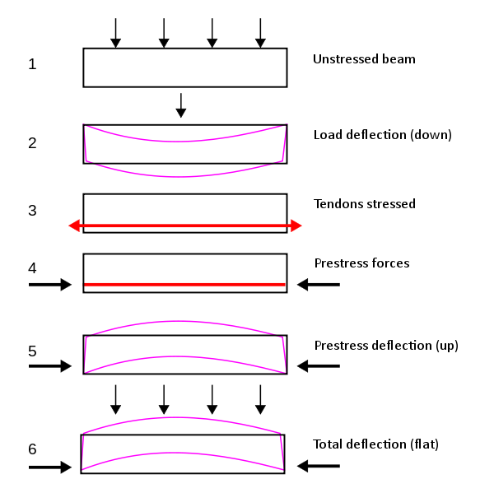

Fig 1.1: Forces in Prestressed Structure

## **1.1 Objectives**

## **1.1.1 General Objectives**

The main objective of this project is to design a technically feasible and economically justifiable prestressed (post-tensioned) RCC bridge.

Detail design with detailed drawings of a bridge of length 200 meters, with spans each of span length 50 meters, comprising of a deck slab of prestressed RCC, Box-girder simply supported on bridge bearings, appropriate abutment/pier, and suitable foundation (footing or pile) based on geological and geotechnical conditions prevalent in the site shall be taken up in this project.

## **1.1.2 Specific objectives**

In addition to the above outlined objectives, following are the specific objectives of this project.

* To carry hydrological survey and verify maximum discharge, design discharge, linear waterway, scour depth, high flood level etc.
* To determine preliminary sizing of bridge structure.
* To calculate and analyse the forces and stresses due to various loading conditions using Python Programming Language.
* To prepare a detailed design of bridge structure along with reinforcement details.
* To prepare necessary drawings like L-section, X-sections, elevations and plans along with detail drawings of bridge structure.

## **1.2 Scope of the study**

The scope of this project covers the following areas:

* Hydrological and Geotechnical Analysis;
* Design of the superstructure: deck slab, intermediate slab, longitudinal girders and cross girders;
* Selection of bearing type; and
* Substructure: abutment, pier and their footing/pile design with load applied as per IRC loading class.

## **1.3 Assumptions and Limitations**

Due to the unavailability of sufficient time and other criteria, this project will be confined to the following limitations:

* Pre-collected data for certain elements, such as topographical maps, geo-technical data, etc, will be used.
* Detailed engineering study of materials to be used for construction of proposed bridge will not be carried out.
* Available schedule, financial support, resources, technology and expectation will be considered.

## **1.4 Immediate output**

After the completion of project, we expect the following outcomes:

* Detailed design of bridge structure;
* Hydrological study report;
* Geo-technical study report;
* Analysis by Excel;
* Estimation of total cost; and
* Final report.

## **1.5 Literature Review**

Every engineering design is the outcome of the past experiences and  
observations. It is necessary to justify the result of the analysis and design  
properly with reference to the pre-existing standard results or the past  
experiences. Structural design is the methodical investigation of the stability,  
strength and rigidity of structures. The basic objective in structural analysis  
and design is to produce a structure capable of resisting all applied loads  
without failure during its service life. Safe design of structures can be  
achieved by applying the proper knowledge of structural mechanics and past  
experiences. It is needed to provide authentic reference to the design made i.e.  
the design should follow the provision made in codes of practices. Use of  
codes also keep the designer on the safe side in case the structure fails within  
its service life.

For this design, certain references and design criteria are taken from  
various sources. The study of different journals, thesis and design aspects are carried out. The primary literary sources used in this project are as follows.

1. **Nepal Bridge Standards – 2067:**

Department of Roads (DOR) formulated this standard with a view to establish a common procedure for design and construction of road bridges in Nepal. This standard provides specifications such as the geometrics, clearances, loading etc. to be followed for the design of any bridge in Nepal, although this standard refers to various Indian Roads Congress’ (IRC) codes of practice for detailed specifications to be followed.

1. **IRC: 6-2017 Standard Specifications and Code of Practice**

**Section II, Loads and Load Combinations:**

The object of the Standard Specifications and Code of Practice is to establish a common procedure for the design and construction of road bridges.

Moving loads of vehicles according to various vehicle classes are presented in this standard. These loads are to be considered in the structural design of the elements of any bridge, according to various load combinations as enumerated in this standard.

1. **IRC: 112-2020 Code of Practice for Concrete Road Bridges:**

The design criteria for detailed structural design of any type of concrete road bridge is to be done as per the specifications present in this standard. This standard features the latest design philosophy of Limit State Design Method, which is a semi-probabilistic design method allowing the designer/s to check that the structure remains fit for use throughout its design life by remaining within the acceptable limits of safety, serviceability, and durability requirements based on the risks involved. Extension of this code for special applications like suspension bridges and cable-stayed bridges is also allowed to the extent applicable, combined with the use of specialist literature for these types of bridges.

1. **IRC: SP: 105-2015 Explanatory Handbook to IRC 112-2011:**

The principal aim of this Explanatory Handbook is to provide the user with guidance on the interpretation and use of IRC: 112 and to present the worked examples. The examples cover topics that are in line with the clauses of the code, and that will be encountered in a typical bridge design.

1. **IS 456:2000 Plain and Reinforced Concrete- Code of Practice:**

This Indian Standard code of practice deals with the general structural use of plain and reinforced concrete based on Limit State Design Method. According to the code, plain concrete structures referred to those structures where reinforcement if provided is ignored for determination of the strength of the structure. This code does not cover special requirements for the structures like bridges, chimneys, hydraulic structures, earthquake resistance buildings etc. but allows the use of separate code for those structures in conjunction with this code.

## **1.6 Methodology**

In order to fulfil the above-mentioned objectives, the following processes and methodology will be adopted.

### **1.6.1 Desk Study:**

Desk study is the study of all scope of the topic of this project which includes literature review, past report review, study of design codes, topographic study, catchment area calculation, study of road and river characteristics and data provided by concerned authorities.

### **1.6.2 Data collection:**

**1.6.2.1 Primary data**

For primary data collection, the topographical survey of selected bridge site is to be carried out in order to study the topographical, geological and hydrological study, both upstream and downstream, of the bridge site.

**1.6.2.2 Secondary data**

The secondary data is to be collected with the help of various authorities like Local Road Bridge Support Unit (LRBSU) along with field questionaries at the locality of the bridge site.

## **1.7 Analysis and design:**

The detailed design of the bridge structure shall be carried out in the following steps:

* The maximum discharge shall be calculated in the river for a 100-year return period with the use of different formulae which shall be used to calculate the linear waterway, velocity, scour depth, foundation depths, etc.
* Based on technical and economic considerations, span and length of bridge required, suitability of a two-span prestressed post tensioned RCC bridge shall be analysed and designed as per the site requirements.
* The river training requirements, soil conditions and requirement of treatments, selection of type of foundation, substructure and superstructure, etc. shall be decided as per site requirements.
* The preliminary design of the bridge parameters such as clear roadway, width of curbs, height of curbs, main girder, cross girder, railings, deck slabs, etc. shall be carried out on the basis of traffic studies as well as codal provisions in concerned NBS, IRC, IS, and AASTHO codes.
* The process of load calculation and preliminary as well as detailed design and analysis process shall be carried out by using python programming language.

Approximate sizing of the structural members will be carried by considering the combination of appropriate dead loads and live loads. The design procedure shall be carried out by manual calculation methods, use of simple excel calculations or the use of python programming language.

The design shall be carried out with the following considerations:

* Loading: Loadings are considered from IRC: 6-2017
* As per existing Road standards, carriage way width, footpath, kerb and height of railing posts are taken.
* Superstructure: According to IRC: 21-2000 (Standard Specification and code of practice for road bridges)
* Bearing: According to IRC: 83-1995 Part II (Design and code of practice for design of elastomeric pad bearing)
* Foundation and Substructure: IRC: 78-2014 Section VII



## **1.8 Time Schedule**

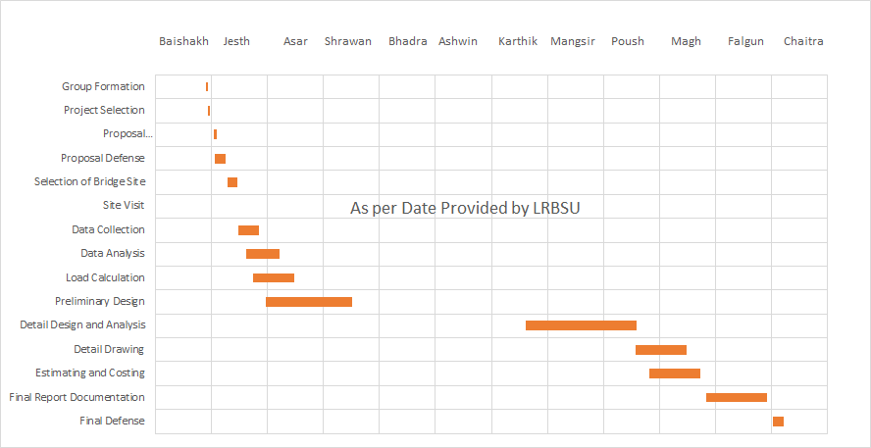

# **CHAPTER II**

## **2.0 Engineering Survey**

Surveying is the technique of determining the relative position of different features on, above or beneath the surface of the earth by means of direct or indirect measurements and finally representing them on a sheet of paper known as plan or map. In the project various data were collected from site in order to draw the contour map of the bridge site, to locate the high flood level and to draw the overall picture of the site and the river.

Topographic survey was carried out to locate the surrounding features in relation to the bridge site. Topographical survey was conducted over a distance of about 600 m upstream, 600 m downstream and about 700 m and 200 m on longitudinal directions. Cross Sections and L-Sections of the river were also located and mapped through autocad.

The general topographic and survey data were provided by LRSBU and later verified by our project group.

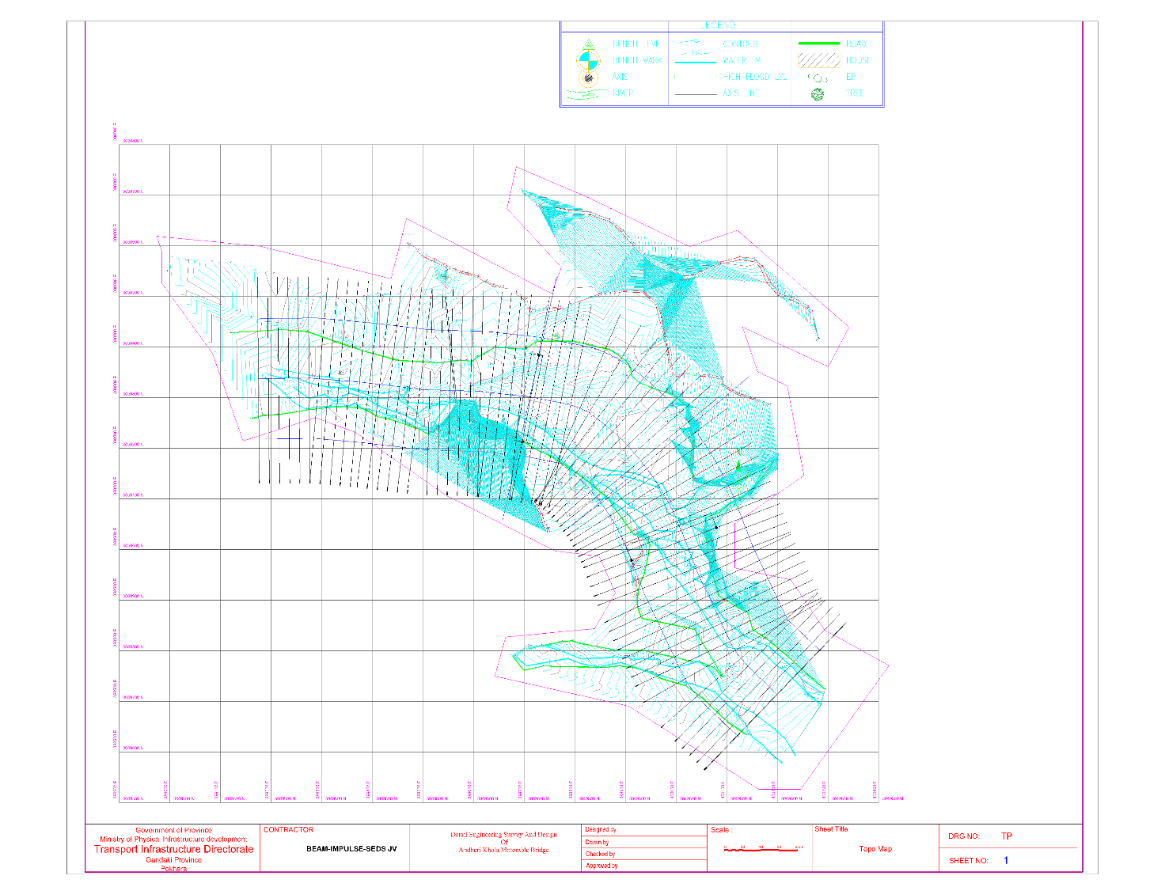

Fig 2.1: Topographical Map of Bridge Site

# **CHAPTER III**

## **3.0 Geological Study**

This geotechnical investigation report (research) is prepared based on the site explorations and laboratory test results carried out by Himalaya Geo solution Pvt. Ltd., Lalitpur.

The proposed bridge site at Mardi Khola at Bhedetar is located in a valley area. As per Geological map of Nepal, the project site lies in Lesser Himalaya of Plio -Pleistocene to Quaternary age composed of fluvial/fluvioglacial gravels, conglomerates and lacustrine clay deposits. Geological map of the project area is shown in Fig. 1. The map is an extract from Geological map of Nepal published by the Department of Mines and Geology of Government of Nepal.

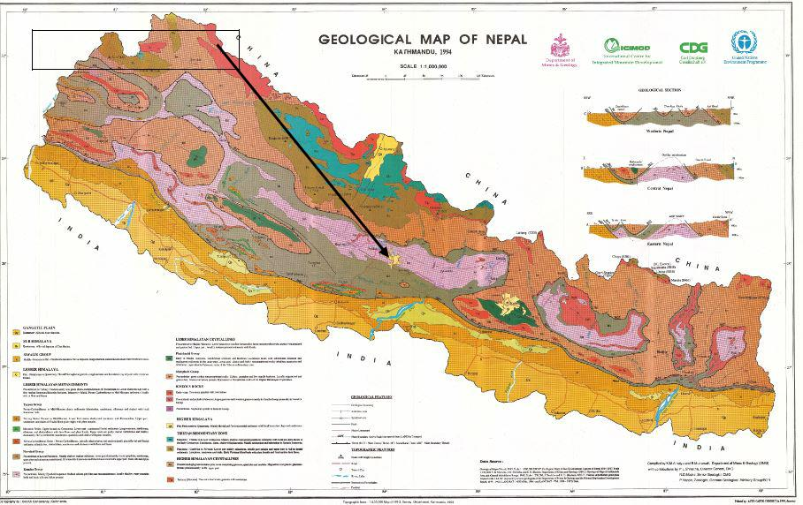

Fig 3.1: Geological map of Nepal including project area

From the exploration record of the boreholes at the proposed site the soil profile of the terrain is as follows: Very dense brownish sandy silty gravels with boulders up to 2-3 m followed by Medium soft medium plastic to low plastic whitish silty clay (kamero mato) up to full depth of exploration i.e., 20 m.

## **3.1 Geotechnical Study**

This geotechnical investigation report (research) is prepared based on the site explorations and laboratory test results carried out by Himalaya Geo solution Pvt. Ltd., Lalitpur.

Geological condition/stratum at the test site is important aspect to determine the depth, size and types of foundation. Drilling can define the characteristic and strength of soil and rock in both unstable and stable zones. Standard Penetration Tests and Dynamic Cone Penetration Tests carried out in different depths can give appropriateness of the densification of the soil strata.

In general, as proposed drilling area lies in gravel area as known from field visit, past experiences and literatures reviewed, the drilling team was mobilized by Rotary Drilling Rig. Safety mechanisms were developed for technical team and workers with safety helmets and safety gloves while working.

### **3.1.1 Boring**

Boring investigation was performed in the subsoil to abstract information of soil state, thickness and depth of layers etc. The subsoil distribution, fractured zone and soft ground shall be grasped for the foundation design of structures depending on boring test results. In addition, in-situ tests, sounding, and underground water level measurement were performed using bore-holes.

The drilling works were carried out by Rotary drilling Rig. The diameter of borehole at borehole locations were of 96 mm. The boreholes were logged continuously in the field. The borehole logs included visual classification of soil, records of SPT for penetration of 450mm and position of ground water table. The borehole logs for site are presented in Annex-I including general ground water table.

### **3.1.2 Sampling**

Before any disturbed samples were taken, the boreholes were washed clean to flush any loose disturbed soil particles deposited during the boring operation. The samples obtained in the split spoon barrel of SPT tube during Standard Penetration Tests were preserved as representative disturbed samples. The disturbed samples recovered in SPT tube were placed in air-tight double 0.5 mm thick transparent plastic bags, labeled properly for identification and finally sealed to avoid any loss of moisture. Only then, the samples were transported to the laboratory for further investigations.

The samples were obtained as per IS 8763: 1978 Guide for undisturbed sampling of sands and sandy soils 1978 Soil and foundation engineering.

No Standard Penetration Samples in Split Spoon Sampler and Undisturbed Samples in Undisturbed Sampling tubes were retrieved due to presence of loose samples.

### **3.1.3 Field Test**

The field test conducted at the site consists of Standard Penetration Test (SPT) and Dynamic Cone Penetration Tests (DCPT). They are the method for measuring soil characteristics of relative density and strength simply and quickly by penetrating resistance into the ground and pulling out it onto the ground. Penetration tests were executed through all strata.

**Standard Penetration Test (SPT)**

A standard split barrel sampler was used in the test. The tests were conducted in the boreholes of the site at a depth interval of every 1.5 m where sample can be extracted. The driving of split-spoon barrel was recorded at first 150 mm and then after at every 150 mm of penetration till the total penetration was 450 mm. The number of blows recorded for the first 150 mm of penetration is disregarded. The number of blows recorded for the last two 150 mm intervals are added and expressed as SPT N-value.

**Dynamic Cone Penetration Test (DCPT)**

It consists of driving a cone by blows of hammers. The number of blows for driving the cone through a specified distance is a measure of the dynamic cone resistance. Dynamic Cone Penetration tests are performed by a 50-mm solid cone. The driving energy is given by a 63.5 kg monkey hammer falling freely through a height of 750 mm onto the drive head. First of all, the cone is driven 100 mm into the soil at the bottom of the bore hole. It is then driven further 200 mm and the number of blows (Ncbr values) required to drive this distance is recorded.

The result i.e., Nc values first corrected to the Standard Penetration Test (SPT) value (N) and that provides and estimation of degree of compaction of soil strata, values of angles of internal friction (Φ) and allowable bearing capacity. The dynamic cone resistance is correlated with the SPT (N) as given below.

Nc= 1.5 N for depth up to 3 m

1 .75 N for depth 3 to 6 m

2 N for depth greater than 6 m

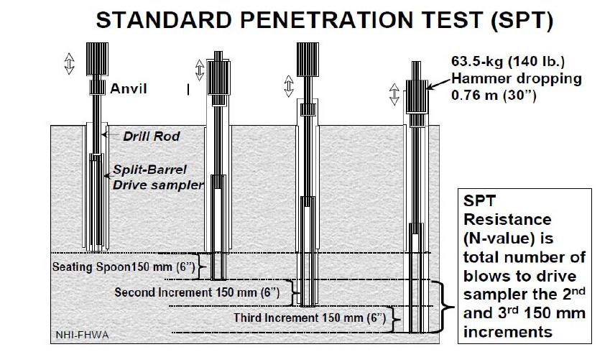

Fig 3.2: Test Procedure of Standard Penetration Test

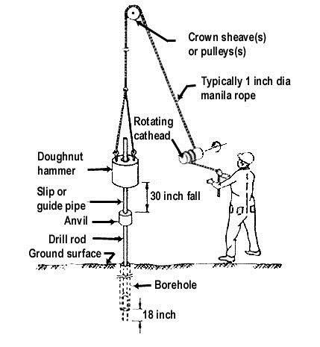

Fig 3.3: Schematic Description of Standard Penetration Test/Dynamic Cone Penetration Test

**Table 3.1: Correlation between N-values and Internal Friction Angles in Granular Soils**



|  |  |  |  |  |  |
| --- | --- | --- | --- | --- | --- |
| **N** | **Relative** | **Relative** | **Internal friction angle, Φ** | |  |
| **Density, Dr** |  |  |  |
| **Value** | **Density** | **Peck (1974)** | **Meyerhof** |  |
| **(%)** |  |
|  |  | **(1956)** |  |
|  |  |  |  |  |
| < 4 | Very loose | 0.0 ~ 15 | < 28.5 | < 30 |  |
|  |  |  |  |  |  |
| 4 ~ 10 | Loose | 15 ~ 35 | 28.5 ~ 30.0 | 30 ~ 35 |  |
|  |  |  |  |  |  |
| 10 ~ 30 | Medium | 35 ~ 65 | 30.0 ~ 36.0 | 35 ~ 40 |  |
|  |  |  |  |  |  |
| 30 ~ 50 | Dense | 65 ~ 85 | 36.0 ~ 41.0 | 40 ~ 45 |  |
|  |  |  |  |  |  |
| > 50 | Very dense | 85 ~ 100 | > 41.0 | > 45 |  |
|  |  |  |  |  |  |



In our analysis, Internal angle of friction was adopted as;

= 15+√(12 ∗.) for sandy soils given by Dunham (1954)

**Table 3.2: Correlation between N-values to Consistency and Unconfined Compression Strength in Cohesive Soils**

|  |  |  |  |  |  |
| --- | --- | --- | --- | --- | --- |
| **N Value** | | **Consistency** | **Unconfined Compression** | |  |
| **Test, qu in kN/m2** | |  |
|  |  |  |  |
| < 4 | | Very soft | < 25 | |  |
|  |  |  |  |  |  |
| 2 | ~ 4 | Soft | 25 | ~ 50 |  |
|  |  |  |  | |  |
| 4 | ~ 8 | Medium Stiff | 50.0 ~ 100 | |  |
|  | |  |  |  |  |
| 8 ~ 15 | | Stiff | 100 | ~ 200 |  |
|  |  |  |  |  |  |
| 15 | ~ 30 | Very Stiff | 200 | ~ 400 |  |
|  | |  |  |  |  |
| > 30 | | Hard | 400 | ~ 800 |  |
|  |  |  |  |  |  |



### **3.1.4 Ground water table monitoring**

Water Table is defined as underground border between the grounds in which all spaces are filled with water and the ground above in which the spaces contain some air. The level of the water table tends to follow the shape of the overlying ground surface, rising under hills and dipping in valleys, but with a gentler slope than the ground. The level of the water table also varies with the climate, rising during rainy periods and falling during dry season.

The position of ground water table was measured at each borehole from the ground surface. The water level observed in the boreholes at the end of a 24 hours long period after completion of boring work was taken as the position of ground water table.

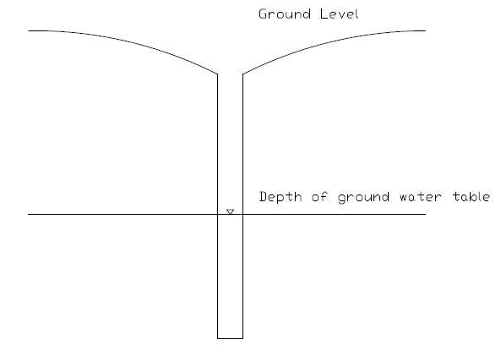

Fig 3.4: Reference point for measuring water level in borehole

### **3.1.5 Seismicity**

Many earth scientists believe that longitudinally the entire 2,400 km long Himalayan arc can be segmented into different individual parts (200-300 km) which periodically break and move separately and produce mega earthquake (catastrophic earthquake) in the Himalayan region. From east to west, the great earthquake of Assam, India (1950), Shilong, India (1897), Nepal-Bihar, India (1934) and Kangra, India (1905) are the mega-earthquakes of the last century produced by the movements in different parts of the Himalayan arc, all with magnitude around 8.0. When a sector of the Himalaya moves and produces earthquakes, it will take some time (from decades to century) to repeat the event at the same place. Nepal is prone to an earthquake of minor or major magnitude. Records of earthquakes since 1253 indicate that Nepal was hit by 16 major earthquakes - the 1833 (magnitude 7.9) and 1934(magnitude 8.3) are two of these which have occurred at an interval of 100 years. Statically, the earthquake occurrence data of the last century shows that in average Nepal was hit by a big earthquake in every 12 years (Nakarmi, 1997).

Statistics shows that 1934 earthquake was the severest for Kathmandu valley where significant damages to the lives and properties were observed. Recently devastating earthquake in April 25th, 2015 causing significant damages to life and properties of the people. The frequency and intensity of earthquakes are found at the weakness of the crust such as major faults and major bends. Location of Nepal in the Himalaya along with major tectonic boundary and various longitudinal zones of the Himalaya is shown in Fig.6.

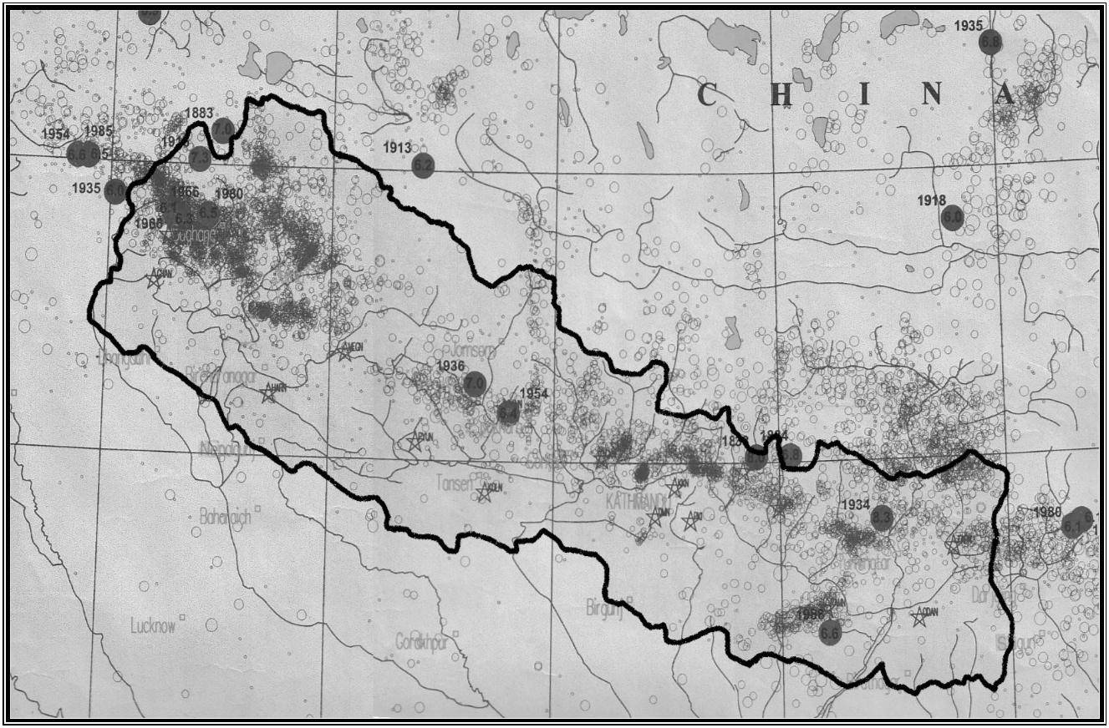

Fig. 3.5: Historical events of Earthquakes (Source: Microseismic epicenter map of Nepal Himalaya and adjoining region, 1997 published by DoMG, GON).

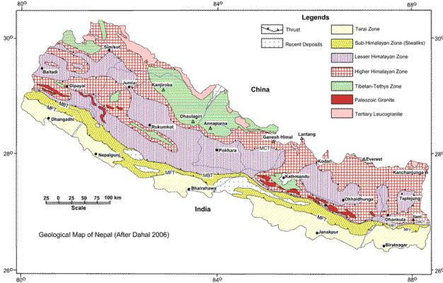

Fig. 3.6: Geological map of Nepal (Dahal 2006)

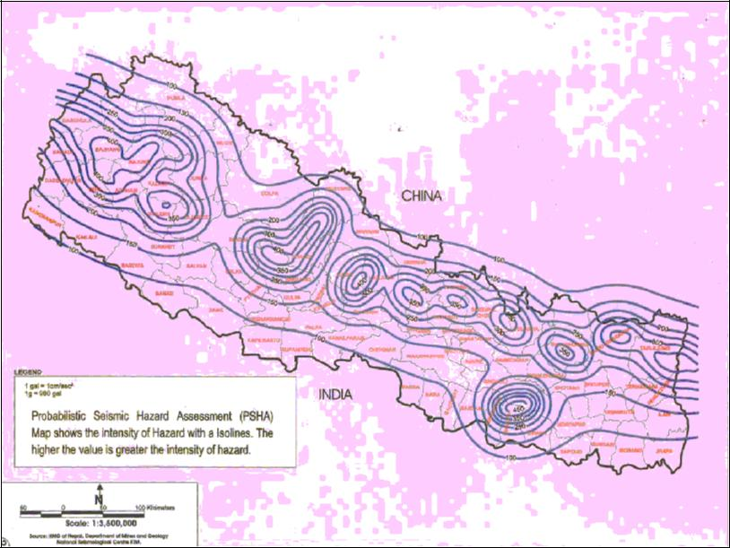

Fig. 3.7: Probabilistic Seismic Hazard Assessment Map of the Nepal Himalaya

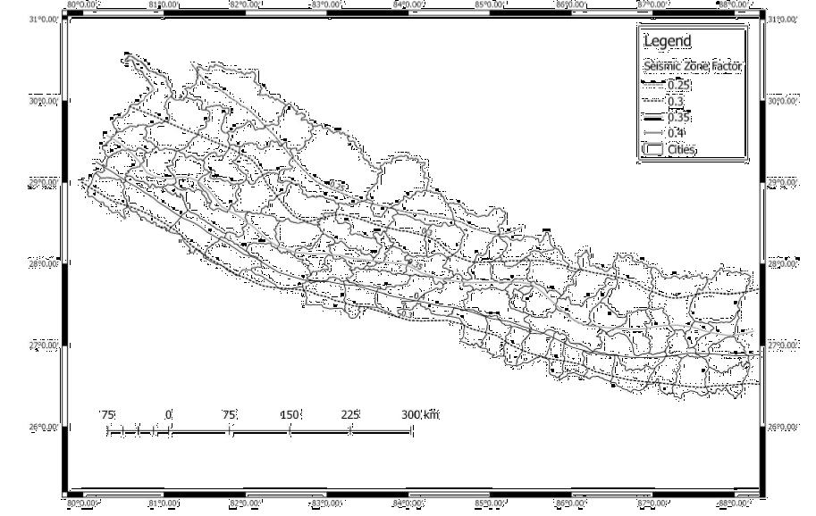

Fig 3.8: Seismic Zone Factor, Z (From Seismic Zoning Map of Nepal)

To counteract earthquake effect, due consideration has to be taken in the structural design of structures as per seismic design as provided by Building Code of Nepal. The project area is located in the area having Seismic Zone Factor, Z, equal to 0.35 according to Seismic Zoning Map of Nepal in Nepal National Building Code NBC: 105: 2020.

### **3.1.6 Liquefaction**

Saturated loose to medium dense cohesion less soils and low plastic silts tend to densify and consolidate when subjected to cyclic shear deformations inherent with large seismic ground motions. Pore-water pressures within such layers increase as the soils are cyclically loaded, resulting in a decrease in vertical effective stress and shear strength. If the shear strength drops below the applied cyclic shear loadings, the layer is expected to transition to a semi fluid state until the excess pore-water pressure dissipates.

**Identification of liquefaction area**

The present site consists of silty clay in general and water table lies at the depth around 2 m in the boreholes from the ground level, so the site is less susceptible to liquefaction.

### **3.1.1 Recommendation of Foundation Type and Depth:**

Based on the analysis, the following recommendations are made:

•Pile foundation is analyzed to calculate the allowable pile capacity for various lengths and dimensions of pile taking pile cap at a depth of 3 m from natural ground level which is summarized below:

|  |  |  |  |
| --- | --- | --- | --- |
| ALLOWABLE LOAD CARRYING CAPACITY OF CAST-  INSITU BORED PILE (IS 2911-1-2) | | | |
| BOREHOLE NO: | MODELLED STRATA BH 1 # 2 # 3 # 4 # 5 | | |
| Depth of Pile Top | 3 m below ground level | | |
| Size of Pile, mm | 1000 | | |
| Length of pile, m | 15 | 18 | 20 |
| ALLOWABLE BEARING | 146 | 184 | 205 |

•The bearing capacity of pile foundation will be based on field SPT N values. During construction phase, pile load test should be carried out strictly to check the ultimate bearing capacity of the pile at five different locations (Abutments and Piers) and then final design should be revised based upon the results of Pile Load Tests. Or additional laboratory tests to verify the design by collecting the samples below 3 m depth by test pits can be done.

•The slope of the excavation should be maintained at about 45° to prevent the slope from collapsing during excavation or construction period.

•Because of presence of seepage water and consideration of probable rise in water table in monsoon, side fall (collapse) is eminent. So, at the time of construction of foundation, it is strongly recommended to design the appropriate site protection measures based on the soil properties shown in this report.

• The above recommendation is based on the mentioned methodology of our analysis. It is worth mentioning that the allowable bearing capacity depends on many variables such as allowable settlement, type of foundation, size and depth of foundation, importance of structure, cost of project etc. Therefore, based on soil index properties data and engineering properties data provided in this report, the foundation designer is free to refine the calculations wherever he feels necessary.

# **CHAPTER IV**

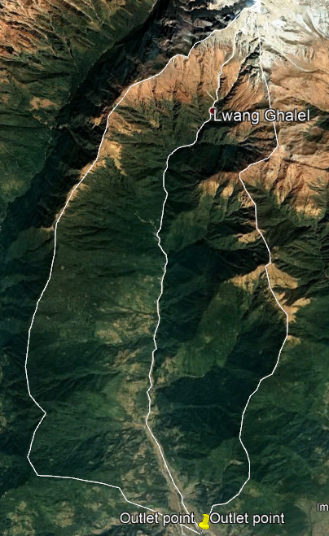

## **4.0 Hydrological Study**

### **4.1 Hydrological Design**

In hydrological analysis catchment area was calculated from topo map.

To calculate design discharge, we apply various methods, and among them, suitable discharge was chosen. In all methods, we choose Return Period: 100 Years

*Outlet point @ 28° 19’ N 18° 54’ E*

The design discharge can be calculated by using various methods as given below:

**Design Parameters:**

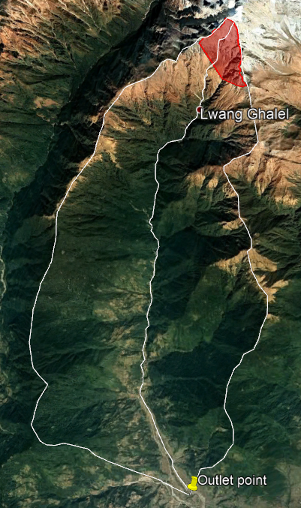Catchment Area = A = 105.7 km2

Figure 4.1 Catchment Area

Area under 3000m = 78,981,907m2

Perimeter under 3000 = 41970m

**Rational Formula**

Q = CIA/360

Where,

L = 21.6 km

S = 4398/21600

= 0.2042

Tc= 78.08 minutes

C = 0.2

Where, K=5.914,

Figure 4.2 Snow covered Catchment area

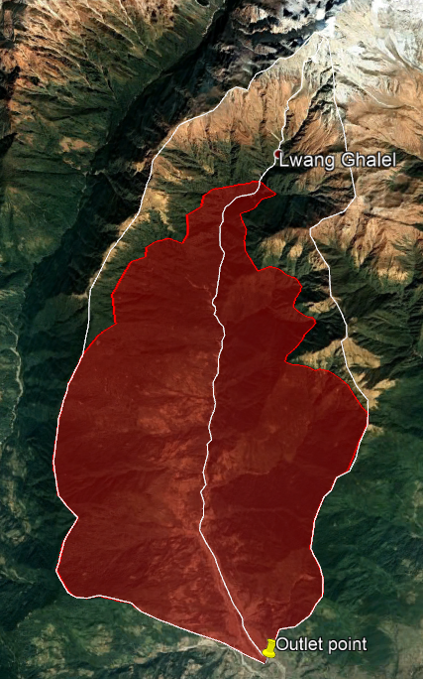 T= 100 years

x= 0.1623

a= 0.50

n= 1.0127

i= 68.8 mm/hr

Q = CiA/360

= 404.01 m3/sec (Taking C = 0.2 for hilly forest)

**Dickens Formula (1865):**

*QP = CDA3/4*

Where Cd = 14

A = 105.7km2

Q = 461.51 m3/s

Figure 4.3 Catchment area under 3000

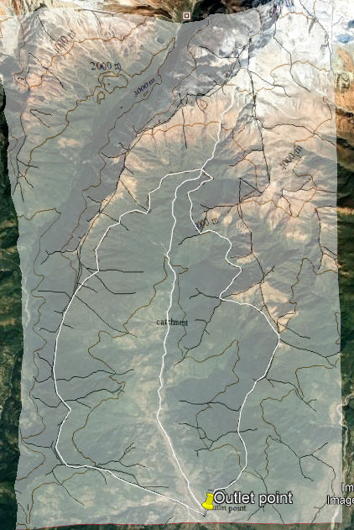**Modified Dickens:**

*Q= CTA3/4*

Where,

T = 100

As = Snow covered catchment area = 1.90km2

= 1.854

Ct = 15.68

Q = 516.89m3/s

**Ryve’s formula:**

*Q= CRA2/3*

Where CR = 10.2

Q = 228.0255m3/s

Figure 4 Contour map overlay and tracing of catchment area under 3000

**WECS Method:**

The formula for 100-year return period is given by  
 Q100=14.63(A3000+1)0.7342

Where,

A3000 = 78.98 km2

Q100 = 365.1m3/s

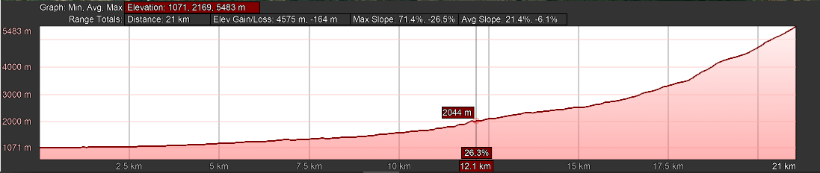

Figure 3.5 River elevation profile

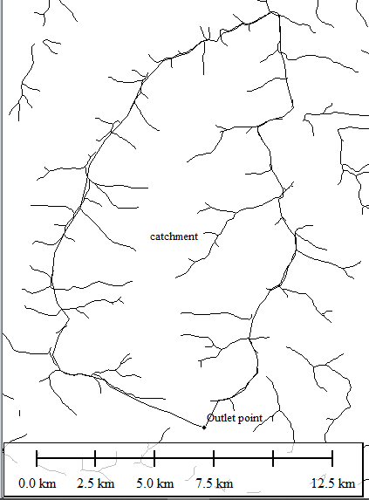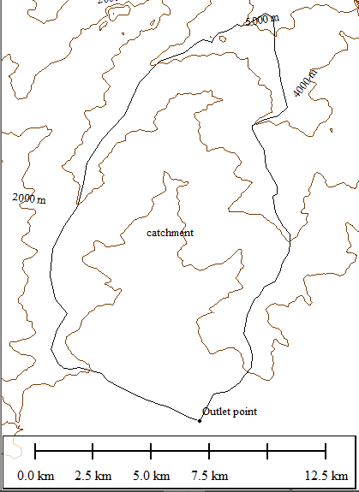

Figure 3.7 Contour map (Interval 1000m)

Figure 3.6 Ridge lines

Table 4.1: Discharge Table

|  |  |  |
| --- | --- | --- |
| **S.N.** | **Method** | **Discharge** |
| 1 | Dicken’s Formula | 461.51 m3/s |
| 2 | Ryves’ Formula | 228.025 m3/sec |
| 3 | WECS | 365.1 m3/sec |
| 4 | Rational method | 404.01 m3/sec |
| 5 | Modified Dicken’s Formula | 516.89 m3/s |

The maximum calculated discharge was used as design discharge for calculations.

Qd =516.89m3/s

**Python Calculations:**

From obtained topographical data of cross section of river at bridge axis and the design discharge, a rating curve was plotted as shown below:

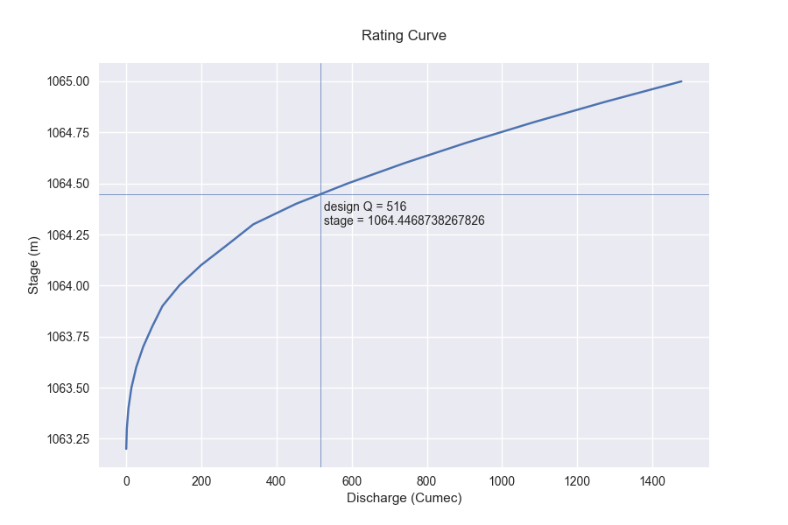

Fig 3.8: Rating Curve

The linear waterway at design discharge was calculated as:

LWW=242.9923 m

The area of Cross section was determined as:

A= 1617.476529

The velocity of flow was calculated as

V=Qd/A=

From obtained topographical data the cross section of river at bridge axis was plotted as follows:

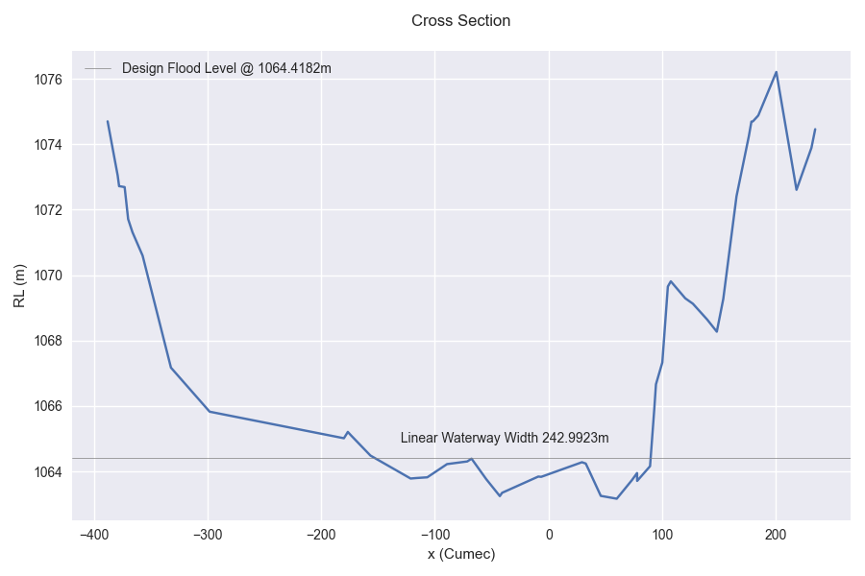

Fig 3.8: River cross section at bridge axis

### 

### **4.1 Site Verification**

**Tribhuvan University**

**Institute of Engineering**

**Thapathali Campus**

**Department of Civil Engineering**

**Levelling Sheet**

Date:2078/8/23

Group no:7?

Members: Aashish Ghimire, Bishal Shakya, Emaduddin Ahmad, Kushal Acharya, Milan Joshi, Nikesh Dawadi

|  |  |  |  |  |  |  |  |  |  |  |  |  |  |  |  |  |  |
| --- | --- | --- | --- | --- | --- | --- | --- | --- | --- | --- | --- | --- | --- | --- | --- | --- | --- |
| S.N. | BS | | | Mean BS | S1=T-B | FS | | | Mean FS | S2=T-B | Rise/Fall +/- | Stadia Interval S=S1+S2 | Hz. Dist. (m) S*100 | Cumul. Hz. Dist. | Distance from right bank | Correct RL | Remarks |
| T | M | B | T | M | B | (m) |
| 1 | 0.98 | 0.912 | 0.845 | 0.912 | 0.135 |  |  |  |  |  |  | 0.135 | 13.5 | 13.5 | 273.3 | 1065.490 |  |
| 2 | 1.485 | 1.4 | 1.31 | 1.398 | 0.175 | 2.24 | 2.16 | 2.08 | 2.16 | 0.16 | -1.248 | 0.335 | 33.5 | 47 | 243.8 | 1064.242 |  |
| 3 | 1.482 | 1.385 | 1.29 | 1.386 | 0.192 | 1.565 | 1.4 | 1.34 | 1.433 | 0.23 | -0.035 | 0.422 | 42.2 | 89.2 | 203.3 | 1064.207 |  |
| 4 | 1.36 | 1.24 | 1.12 | 1.24 | 0.24 | 1.84 | 1.76 | 1.67 | 1.753 | 0.175 | -0.368 | 0.415 | 41.5 | 130.7 | 166.6 | 1063.84 |  |
| 5 | 1.2 | 1.095 | 0.985 | 1.093 | 0.215 | 0.985 | 0.87 | 0.76 | 0.872 | 0.225 | 0.368 | 0.44 | 44 | 174.7 | 120.1 | 1064.208 |  |
| 6 | 1.27 | 1.16 | 1.055 | 1.162 | 0.215 | 1.88 | 1.78 | 1.67 | 1.775 | 0.21 | -0.682 | 0.425 | 42.5 | 217.2 | 77.6 | 1063.526 |  |
| 7 |  |  |  |  |  | 1.647 | 1.52 | 1.4 | 1.521 | 0.251 | -0.36 | 0.251 | 25.1 | 242.3 | 31 | 1063.167 | Lowest Bed Lvl. |
|  |  |  |  |  |  |  |  |  |  |  | -2.323 |  |  |  |  |  |  |

**Site Measurements,**

Approximate river width ≈28m

Total measured distance on site=242.3+28+8 ≈ 278.3m

Approximate deepest flow depth ≈38 cm

Width of right bank ≈ 8 m

**Design Data,**

Total Linear Waterway calculated from 100-year design flood = 243 m

HFL before construction= 1064.418m

Lowest Bed Level at design section = 1063.167m

Design high flood depth = 1.2512m

**Check,**

HFL at 243m LWW as measured on site = 1064.242 m < Calculated HFL at section (OK)

Hence the approximate check on section is ok and design can proceed as calculated from 100-year maximum flood.

# **CHAPTER V**

## **Detailed Design**

## **Overall planning of bridge**

Necessity

A bridge’s life span extends decades into the future, requiring careful planning in

every aspect of its design and construction. A thorough understanding of

construction processes, long-term maintenance issues, and environmental impacts

is vital to the provision of value-added concept design.

It is necessary to provide on particular location in order to:

* To give access to highway nearby.
* For market access, transportation, movement.
* It decreases the length of travel and saves time thereby saving cost of transportation.

Traffic study:

On the basis of present and anticipated traffic life and the probable load that can

pass through the bridges dead load, class A, class AA loading has been used for the

analysis and design.

Location of bridges: location of bridges is selected with keeping with following view

point

* Shortest length of axis
* River bank soil condition
* Approaching road
* Foundation condition

Reconnaissance study:

It includes full depth and overall study of existing environment. The following

topics are studies under reconnaissance survey.

* Temperature variation
* Humidity
* Rainfall
* Water intensity
* Soil bearing capacity
* Earthquake stud

Preliminary engineering:

It includes the following activities

* Development of plan, Architectural drawing
* Preliminary design
* Risk analysis
* Final choice on the basis of economic and technical feasibility

Reconnaissance study report is prepared and final detailed design with working

drawing is prepared for implementation of project.

## **Bridge Type Selection Criteria**

Following are the alternatives for the selection of bridge type:

Span Ranges for Different Type of Bridges Usually Followed by India Based on

Technical and Economic Factors:

|  |  |  |
| --- | --- | --- |
| S.N. | Type of Bridge | Span(m) |
| 1 | R.C. Slab | 6-10 |
| 2 | R.C. T-Girder | 10-30 |
| 3 | Composite | 25-40 |
| 4 | R.C. Box | 30-50 |
| 5 | Pre-stressed Concrete Box | 40-80 |
| 6 | Arch Bridge |  |
| 7 | Masonry | 15-30 |
| 8 | Concrete | 40-70 |
| 9 | Steel | 50-100 |
| 10 | Cable stayed | 100-200 |
| 11 | Suspension | 300-2000 |
| 12 | Truss | 25-300 |

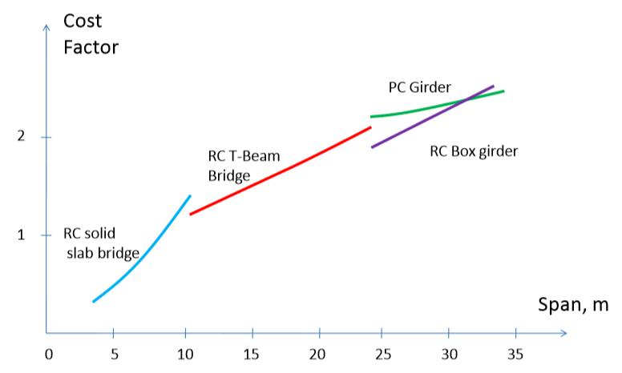

Fig: Type of Bridge based on its Cost and Span

## **Bridge Type Selection Criteria**

For the length of 200m of bridge, 4 spans each of length 50m will be provided. The abutment shall be provided for depth beyond maximum scour level and adequate vertical clearance off HFL shall be made available underneath the decks.

## **Arrangements of bridge components**

Foundation is laid at required depth use to transfer the whole bridge load to soil

over which abutment is placed. The connection between footing and abutment is

assumed to be rigid. Dirt wall is constructed on stem of abutment for retaining soil

sliding towards bearing. Abutment cap is used for transformation of load from

bearing to stem of abutment. Bearing separates superstructure and substructure

of bridge. Here elastomeric bearing has been used as per technical and economic

feasibility and it is placed on abutment cap. All the expected load on bridges is

supported by slab, transfer through girders to bearing and then substructure.

## **Types of Material required**

Bearing materials: Neoprene (synthetic rubbers) and steel. Steel is embedded

inside the neoprene.

## **Material characteristics**

Pre-stressed concrete has a number of properties:

* The characteristic strength of pre-stressed concrete used in the
* construction of bridge are 35 MPa and 60 MPa.
* It can provide high strength with less cross section.
* Porosity and density:

The denser (or the less porous) the concrete the better its performance and the

greater its durability. The density of concrete is increased by optimizing the

dimensions and packing of the aggregate and reducing the water content.

* Fire resistance.
* Thermal and acoustic insulation properties.
* Impact resistance - As concrete cures it shrinks because the water not

used for hydration gradually evaporates from the hardened mix

Concrete, like also undergoes volume changes due to thermal effects

Since concrete is weak in tension, it will often develop cracks due to

such shrinkage and temperature changes. So, consider a freshly placed

concrete slab concrete slab-on-grade.

Characteristics of HYSD Rebar:

* Low carbon value – HYSD Bars have lower carbon level, resulting in
* good ductility, strength and welding ability.
* Superior bonding strength – HYSD bars are well known for their
* excellent bonding strength when used with concrete.
* Welding capability – Since these bars have lower carbon content,
* they have 100% welding capability than conventional bars.
* High tensile strength – HYSD bars feature high tensile strength. They
* offer great asset in construction process, where a lot of bending and
* re bending is required.
* Wide application range – These bars have wide application range like
* in building residential, commercial and industrial structures, bridges,
* etc.
* Satisfactorily malleability – Minimum weight and maximum strength
* and suitable for both compression and tension reinforcement.
* Characteristics of elastomeric Bearing (neoprene):
* With the increase in the aging time and thermal aging compressive
* capacity, ultimate compressive strength, compressive elastic
* modulus of laminated neoprene bearing pad decreases.
* After thermal aging, bearing is prone to more brittle failure.

## **Geometry Design of Bridge Deck**

### **Superstructure:**

i) Width of carriage way = 6m

ii) Width and Height of Safety Kerb:

* Width of Kerb = Offset + Width of railing post + min. clearance from post = 0.875m
* Height of Kerb > minimum height from road surface = 225mm
* Height of wearing course = 50mm at edges and 110mm at center

iii) Type of wearing coat

Asphalt concrete for wearing coat of bridge. Thickness of wearing course is taken

50mm at edge and 110mm at crown of carriage way to give about 2.5% camber.

iv) Type of Railing:

* GI Pipe with RC post as railing.
* RC post of 225mm × 225mm × 1100mm
* Number of post = 16 at 2.1 m spacing on each side.
* Railing should have minimum height of 1.1m above roadway.
* Clear distance between lower rail and top of kerb shall not exceed
* 150mm.

v) Size of RC slab:

* 300mm thickness of slab.
* 300 x 150mm fillet at the ends.

vi) Size of Main girder:

* Width of web of main girder= 300mm
* Depth of main girder=2.4m
* Depth of flange=300mm
* Effective spacing of girder = 3m

vii) Size of cross girder:

* Width of web= 300mm
* Depth of girder= 1800mm
* Number of cross beam= 5
* Spacing=8.75 m

### **Bearing:**

* Type: Elastomeric Bearing
* Bearing of size = 300x500x52 mm
* Number of bearing with pins= 3
* Number of bearing without pins = 3

### **Sub-structure:**

i) Dirt wall

* Size = 2139x600x7300 mm

ii) Abutment cap:

* Size = 1575x300x7300 mm
* Grade of concrete M20
* Grade of Steel Fe 415

iii) Abutment stem and footing:

* Stem Height = 9261 mm
* Stem Width = 1500 mm
* Stem Length = 7300 mm
* Grade of concrete for abutment stem M20
* Grade of Steel for abutment stem Fe 415
* Footing Size = 10500x7300x2000 mm
* Depth of footing = 2000 mm
* Grade of concrete for footing M20
* Grade of Steel for footing Fe 41

## **Transverse Design of Box:**

## **Longitudinal Design of Box:**